**JAVASCRIPT BASIC & DOM**

**1. What is JavaScript?**

**ANS**: JavaScript is a computer Programming language used to make websites

And applications dynamic and interactive. It’s unique because it can run

Directly in your browser, not just on a server.

**2. What is the use of isNaN function?**

**ANS**: isNaN in JavaScript is a function used for determining whether the given

Value is a valid number or is not a number.

**3. What is negative infinity?**

**ANS**: in JavaScript negative infinity is a constant number used to indicate the

lowest possible value. Infinity is a concept that tells us that something

has no end or it exists without any limit or boundary. It indicates a state

of endless.

**4. Which company developed JavaScript?**

**ANS**: The first JavaScript engine was created by Brendan Each at Netscape.

After Netscape handed JavaScript over to ECMA, the Mozilla foundation

continued to Develop JavaScript for the Firefox browser.

**5. What are undeclared and undefined variables?**

ANS: The main difference between “undefined” and “not defined” is that

“Undefined “is a value that can be assigned to a variable, while “not

Defined “indicates that a variable does not exits.

**6. Write the code for adding new elements dynamically?**

**ANS:**

<!DOCTYPE html>

<html lang="en">

<head>

    <meta charset="UTF-8">

    <meta name="viewport" content="width=device-width, initial-scale=1.0">

    <title>Document</title>

</head>

<body>

    <button id="button">add elements dynamically</button>

    <h3 id="heading_A"></h3>

    <h5 id="alert"></h5>

    <script>

        const button = document.getElementById('button');

        const text = document.getElementById('heading_A');

        const alrt = document.getElementById('alert');

        button.onclick = () => {

            const name = prompt('What is your name?');

            const course = prompt('Which Course we are learning ?');

            alert(`Hello ${name}, Welcome to Tops ...!`+ "\n" + `We are learning ${course}`);

            text.textContent = `Welcome ${name}to our Tops...!` + `We are learning ${course}`;

           alert(button.textContent);

           text.textContent = `Welcome ${name}to our Tops...!` + `We are learning ${course}`;

      }

    </script>

</body>

</html>

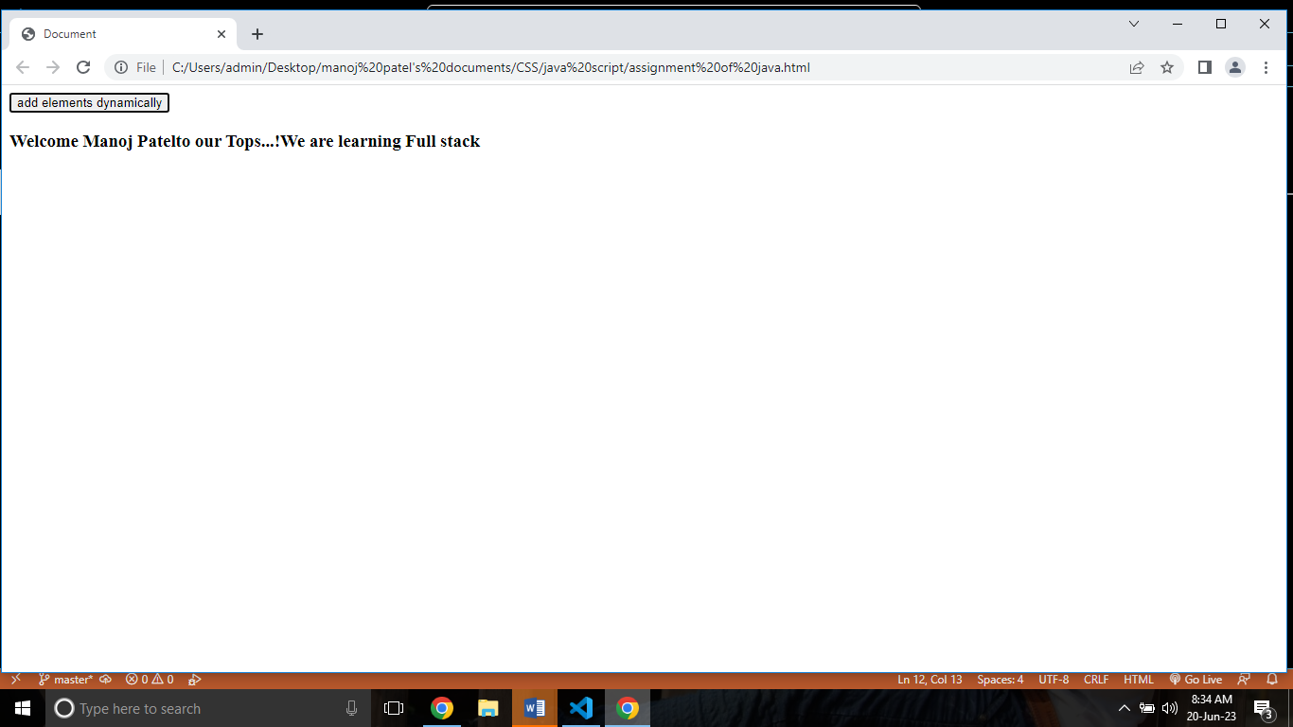

**7. What is the difference between View State and Session State?**

**ANS**: View State: View State is saved in the page. The View State is posted

on Subsequent post back in a hidden field.

Session State: Session State is saved on the server. Session sate is

usually cleared after a period of inactivity from the user.

**8. What is === operator?**

**ANS:** The === operator means “is exactly equal to” matching by both value

and data type.

<!DOCTYPE html>

<html lang="en">

<head>

    <meta charset="UTF-8">

    <meta name="viewport" content="width=device-width, initial-scale=1.0">

    <title>Document</title>

</head>

<body>

    <h1>JavaScript Comparison</h1>

<h2>The === Operator</h2>

<p>Assign 5 to x, and display the value of the comparison (x === 5):</p>

<p id="demo"></p>

<script>

let x = 5;

document.getElementById("demo").innerHTML = (x === 5);

</script>

</body>

</html>

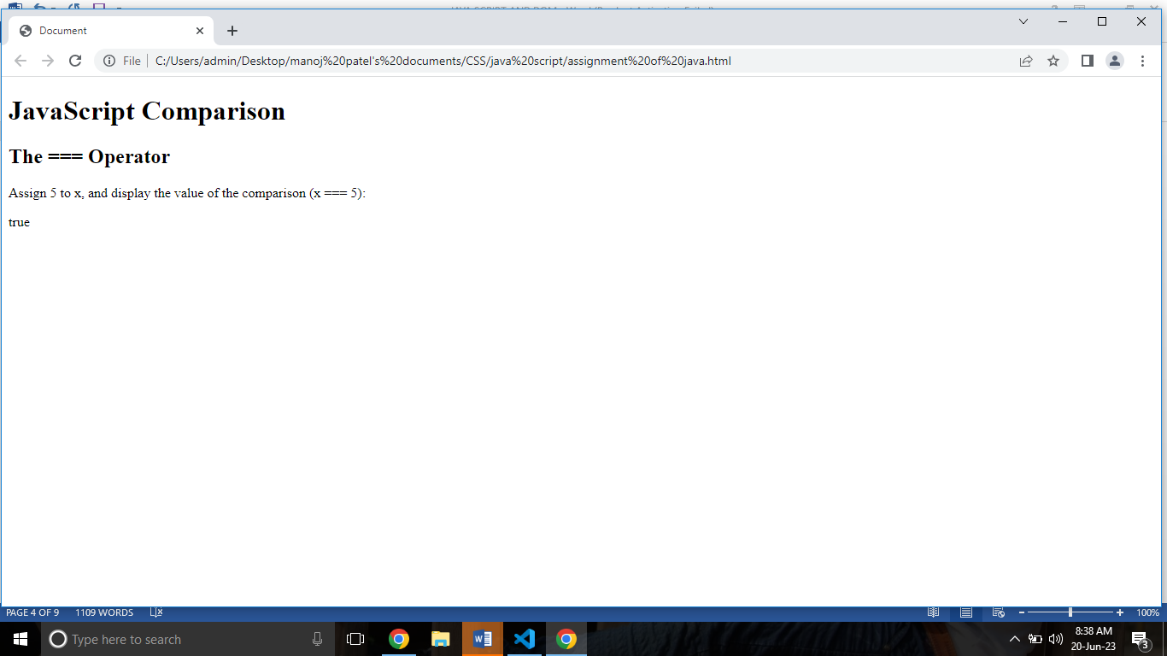

**9. How can the style/class of an element be changed?**

**ANS:**

<!DOCTYPE html>

<html lang="en">

<head>

    <meta charset="UTF-8">

    <meta name="viewport" content="width=device-width, initial-scale=1.0">

    <title>Document</title>

</head>

<body>

    <h1 style="color: green;">

        GeeksforGeeks

    </h1>

    <h2>

        How can the style/class of

        an element be changed?

    </h2>

    <b>Validate Pan Number</b>

    <input type="text" id="pan" />

    <p></p>

    <button id="submit">Validate</button>

    <script>

        const btn = document.getElementById("submit");

        btn.addEventListener("click", function () {

            const pan = document.getElementById("pan").value;

            const para = document.querySelector("p");

            let regex = /([A-Z]){5}([0-9]){4}([A-Z]){1}$/;

            if (regex.test(pan.toUpperCase())) {

                para.innerHTML = "Hurrey It's correct";

                // Inline style

                para.style.color = "green";

            } else {

                para.innerHTML = "OOps It's wrong!";

                // Inline style

                para.style.color = "red";

            }

        });

    </script>

</body>

</html>

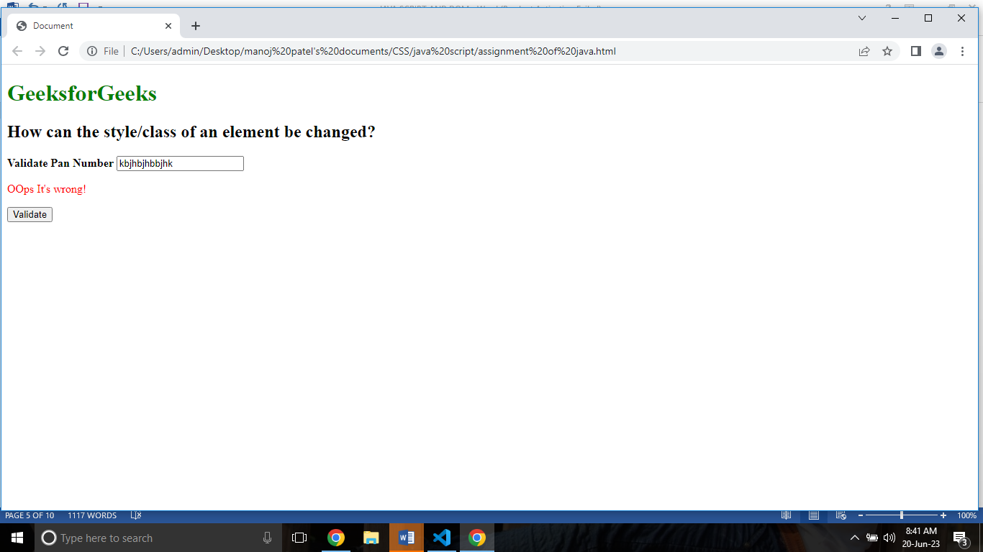

**10. How to read and write a file using JavaScript?**

ANS: The[fs.readFile ()](https://www.geeksforgeeks.org/node-js-fs-readfile-method/) and [rs.writeFile ()](https://www.geeksforgeeks.org/node-js-fs-writefile-method/) methods are used to read and write

Of a file using JavaScript. The file is read using the fs.readFile () function,

which is an inbuilt method. This technique reads the full file into memory

and stores it in a buffer.

<!DOCTYPE html>

<html lang="en">

<head>

    <meta charset="UTF-8">

    <meta name="viewport" content="width=device-width, initial-scale=1.0">

    <title>Document</title>

</head>

<body>

    <script>

        var fs = require("fs");

        console.log(" Writing into an file ");

        // Sample.txt is an empty file

        fs.writeFile(

        "sample.txt",

        "Let's write a few sentences in the file",

        function (err) {

            if (err) {

            return console.error(err);

            }

            // If no error the remaining code executes

            console.log(" Finished writing ");

            console.log("Reading the data that's written");

            // Reading the file

            fs.readFile("sample.txt", function (err, data) {

            if (err) {

                return console.error(err);

            }

            console.log("Data read : " + data.toString());

            });

        }

        );

        </script>

</body>

</html>

**11. What are all the looping structures in JavaScript?**

**ANS**: JavaScript supports different kinds of loops:

for - loops through a block of code a number of times

for/in - loops through the properties of an object

for/of - loops through the values of an iterable object

while - loops through a block of code while a specified condition is true

do/while - also loops through a block of code while a specified condition

is true.

**12. How can you convert the string of any base to an integer in JavaScript?**

**ANS :**

<!DOCTYPE html>

<html lang="en">

<head>

    <meta charset="UTF-8">

    <meta name="viewport" content="width=device-width, initial-scale=1.0">

    <title>Document</title>

</head>

<body>

    <script>

        let age = "23";

        let name = "Manya";

        const number = '100';

        console.log(+age);

        console.log(+name);

        console.log(+number);

        </script>

</body>

</html>

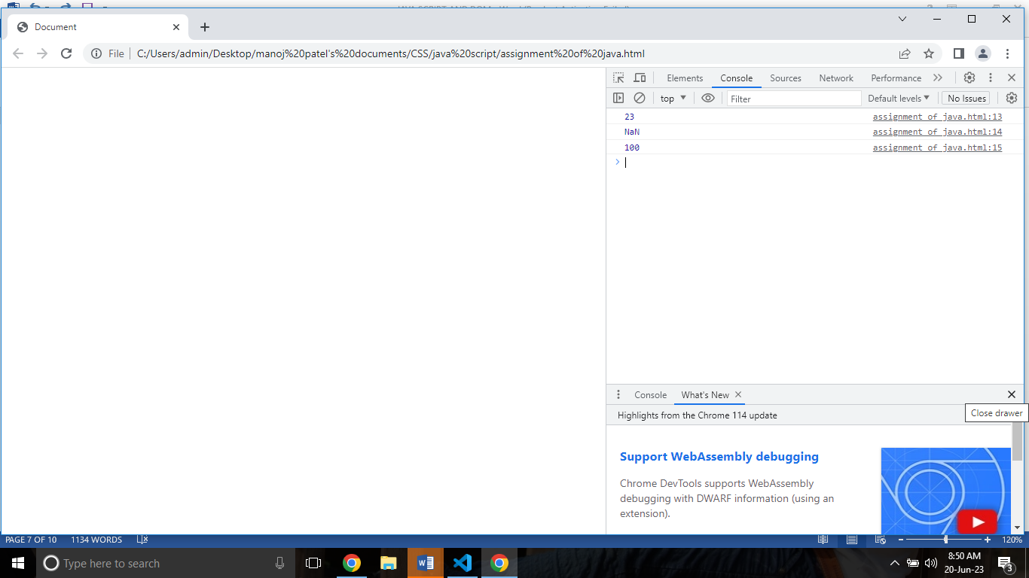

**13. What is the function of the delete operator?**

**ANS:** This operator returns true if it removes a property. While deleting an

object property that doesn’t exist will return a true but it will not affect

the object. Though while trying to delete a variable or a function will

Return a false.

**JavaScript :**

**let emp = {**

**firstName: "Raj",**

**lastName: "Kumar",**

**salary: 40000**

**}**

**console.log(delete emp.salary);**

**console.log(emp);**

**output:**

**true**

**{"firstName":"Raj","lastName":"Kumar"}**

**14. What are all the types of Pop up boxes available in JavaScript?**

**ANS**: JavaScript has three types of popup boxes:

Alert box, confirm box and prompt box

**15. What is the use of Void (0)?**

**ANS:** The void operator to is used to evaluate an expression and returns the

Undefined. Generally, this operator is used for obtaining the undefined

primitive value.

<!DOCTYPE html>

<html lang="en">

<head>

    <meta charset="UTF-8">

    <meta name="viewport" content="width=device-width, initial-scale=1.0">

    <title>Document</title>

</head>

<body>

    <script>

        const output = void 1;

        console.log(output);

        // Expected output: undefined

        void console.log('expression evaluated');

        // Expected output: "expression evaluated"

        void function iife() {

          console.log('iife is executed');

        }();

        // Expected output: "iife is executed"

        void function test() {

          console.log('test function executed');

        };

        try {

          test();

        } catch (e) {

          console.log('test function is not defined');

          // Expected output: "test function is not defined"

        }

            </script>

</body>

</html>

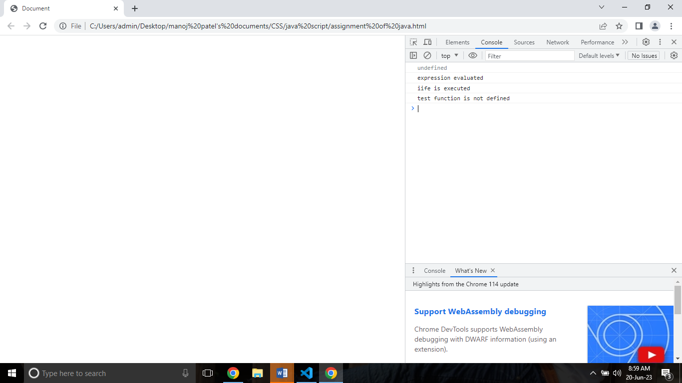

**16. How can a page be forced to load another page in JavaScript?**

**ANS:** In JavaScript, we can use window. Location object to force a page to load

another page. We can use the location object to set the URL of a new

page. There are different ways – window.location.href property,

window.location.assign () and window.location.replace () methods, to set

the URL of a new page using the location object.

**17. What are the disadvantages of using innerHTML in JavaScript?**

**ANS:** **Disadvantages of innerHTML**

* + Event handlers attached to any DOM element are preserved.
  + Replacement is done everywhere.
  + It is not possible to append innerHTML.
  + Breaks the documents.
  + Used for Cross-site Scripting.